Mohammed Faraz Ali, I.D. - 108185032

**Objective:** To detect and recognize lionfish in deep oceans to determine migration patterns

**Introduction**: - This project deals with the detection and recognition of the lionfish by creating our own Haar classifier. This project was inspired from our open CV class and also from the fact how venomous a lion fish is. Therefore it is increasingly evident to detect such species.

**Description**: - The first step of this project is to collect data. The data here means the positive and negative images. The positive images are the images which has your object to be recognized in it, in our case it would be a lion fish. The negative images are the background images and should never contain the object to be recognized. I wrote a python script to grab 1200 negative images and 1000 positive images from *image-net.org*. This script labels the images in numeric order, converts it to gray scale and finally saves it as a .bmp file. Saving as .bmp file because the tool to that I’ve used to annotate the positive images works only with .bmp files.

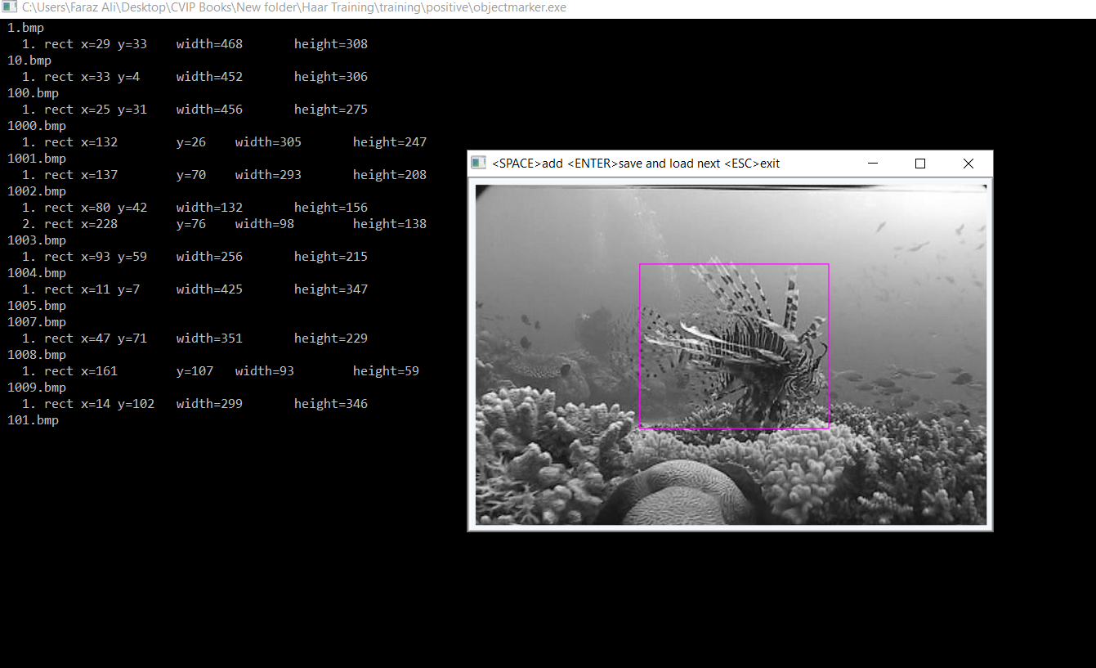

Figure - Showing the use of object marker tool

The positive images are then annotated to get the location of the lion fish. This is done by object marker tool in windows. This tool also creates the positive descriptor file which contains the location of the file, the number of objects, the x coordinate, the y coordinate, and the width and height of the object. This is saved as info.txt file. I then wrote a python script to create the negative descriptor file which only contains the location of the negative images. This is saved as bg.txt file. Interestingly, the descriptor files are just ordinary text files. I have used a windows OS for all the process described above.

Now, for training I have used a Linux based OS- Ubuntu, simply because the process is easier than a windows OS. I now transfer all my files to my Linux machine. Before training, we first need to create a vector file, .vec file which contains the cropped images of the object detected in the positive images. This is done by the command

*opencv_createsamples -info info/info.txt -num 1000 -w 20 -h 20 -vec positives.vec*

In this command, we just let it know where the info file is and how many images we want to contain in the file, what dimensions the images should be in this vector file, and then finally where to output the results. We can make these larger if we like, 20 x 20 is probably good enough, and the larger we go, the exponentially longer it will take to run the trainer.

We now create a new directory called data which were we will output our cascade.xml. The command we used to train is

*opencv_traincascade -data data -vec positives.vec -bg bg.txt -numPos 800 -numNeg 1000 -numStages 23 -w 20 -h 20*

Here, we say where we want the data to go, where the vector file is, where the background file is, how many positive images and negative images to use, how many stages, and the width and height. Note that we use significantly less numPos than we have. This is to make room for the stages, which will add to this.

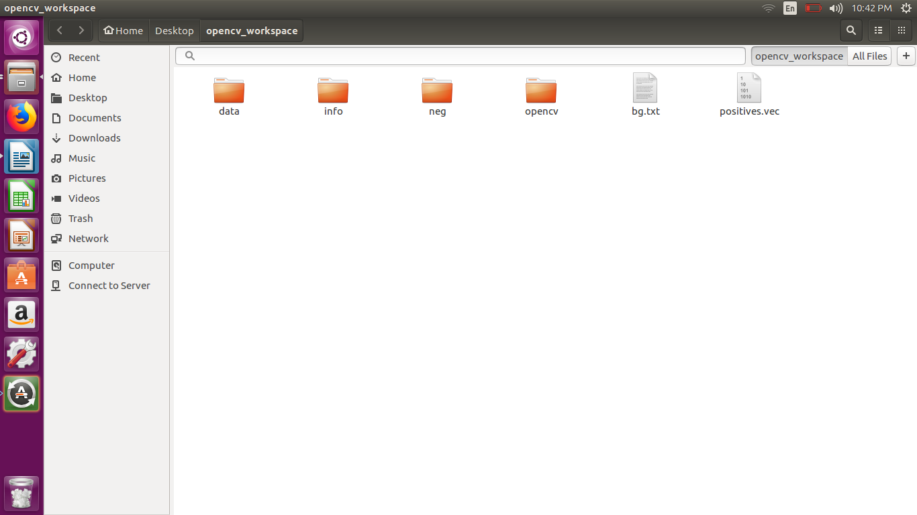

Figure - Showing opencv_workspace directory

The General consensus is, for most practices, you want to have 1:2 ratio of pos:neg images. Some situations may differ, but this is a general rule people seem to follow. The larger the dimensions the more features can be calculated and the more weak classifiers will be gathered for the boosting process. This also influences the amount of memory needed by the application, since all weak classifiers are stored in RAM memory during the process. If the application crashes due to not enough memory, we will need to reduce our model size. The dimensions specify the smallest object size we will be able to detect. Objects larger than that will be detected by the multiscale image pyramid approach. Smaller objects will be ignored since upscaling images to be able to detect them introduces way to much clutter and rescaling artefacts.

Next, we have stages. I chose 23, the more, the longer it will take, and it is again exponential. The first stage is pretty fast usually, stage 5 much slower, and stage 50 is forever! So, we do 23 stages for now. The good thing here is we can train 10 stages, come back later, change the number to 20, and pick up right where we left off. This would create our cascade.xml file.

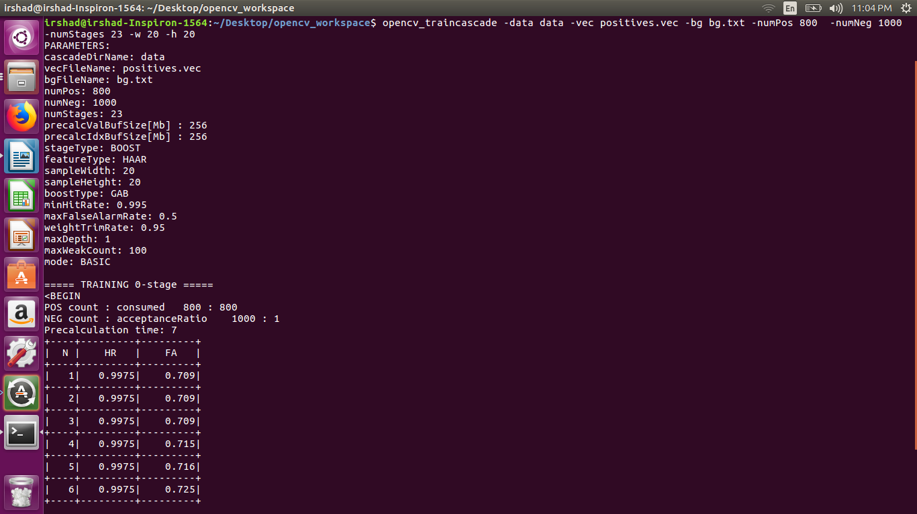

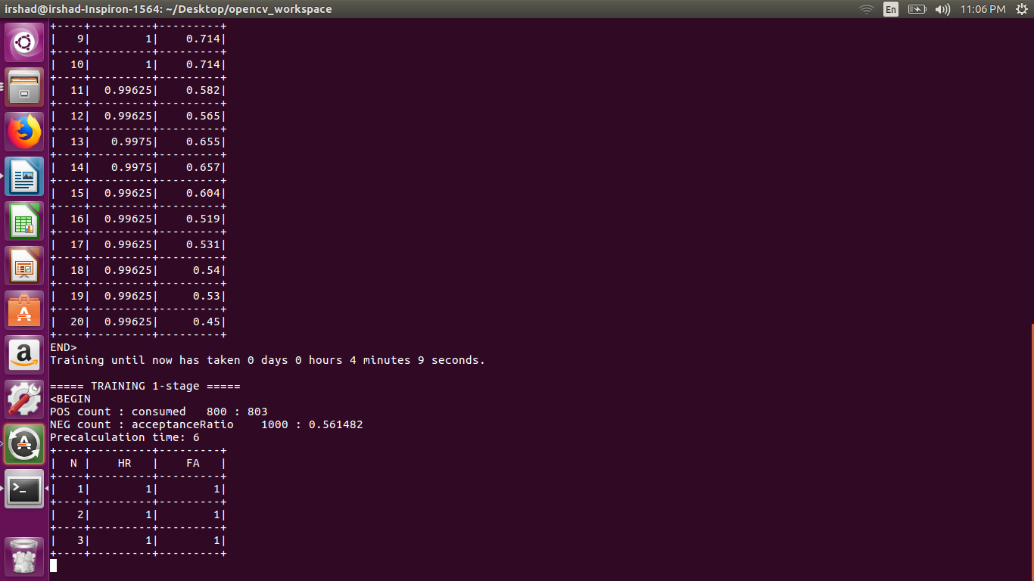

Figure - Showing training on Linux machine

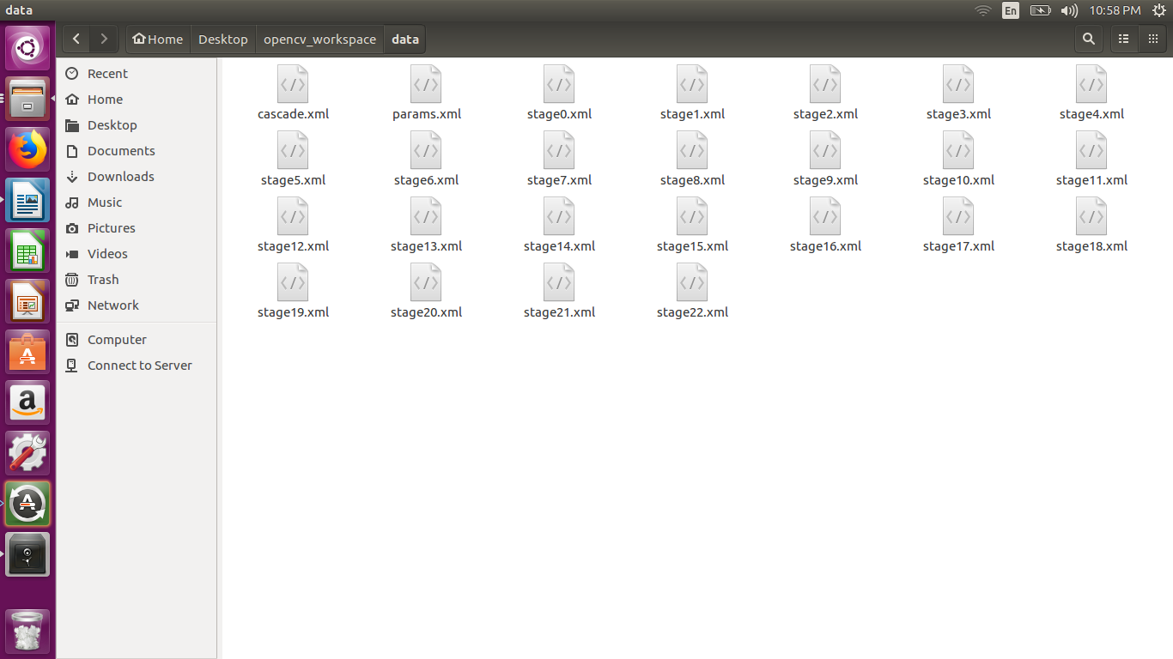

Figure - Showing the classifiers created for 23 stages

Now we can use a face detection algorithm and detect the lion fish and draw a rectangle bounding box around it. 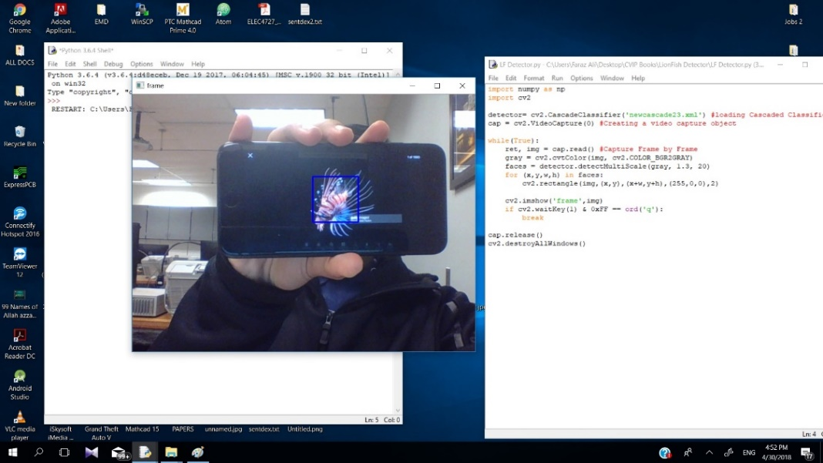

Figure - Showing lionfish detected

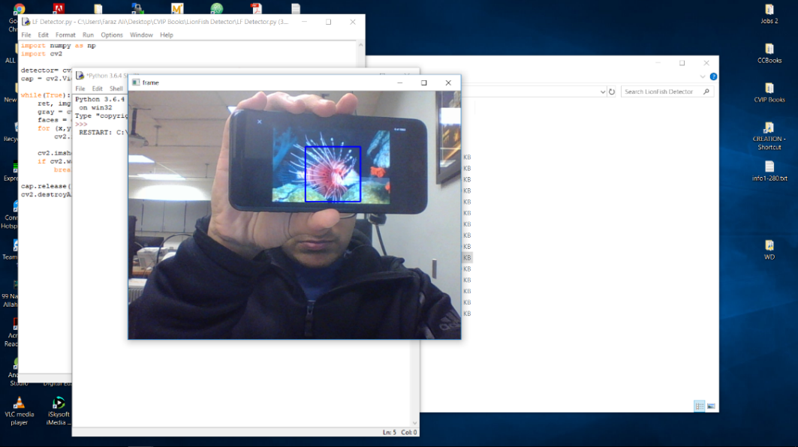

Figure - - Showing lionfish detected

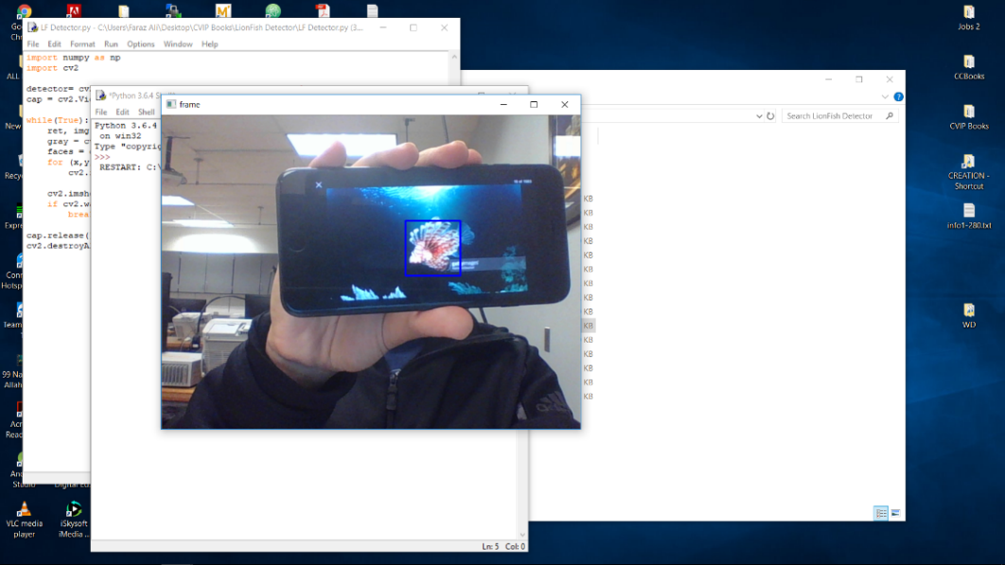

Figure - Showing lionfish detected

**Lionfish Recognition: -**This section deals with the recognition part of our project. To recognize the lionfish I created 3 python scripts datasetcreator, trainer and detector.

***a) Datasetcreator*-** This program creates samples i.e. it captures the faces (lionfish) and labels it. I call the labels here an ID. We create 21 samples for each new lion fish detected and save it as user.id.sample_number.jpg, in a folder called dataset. These images will be in gray scale.

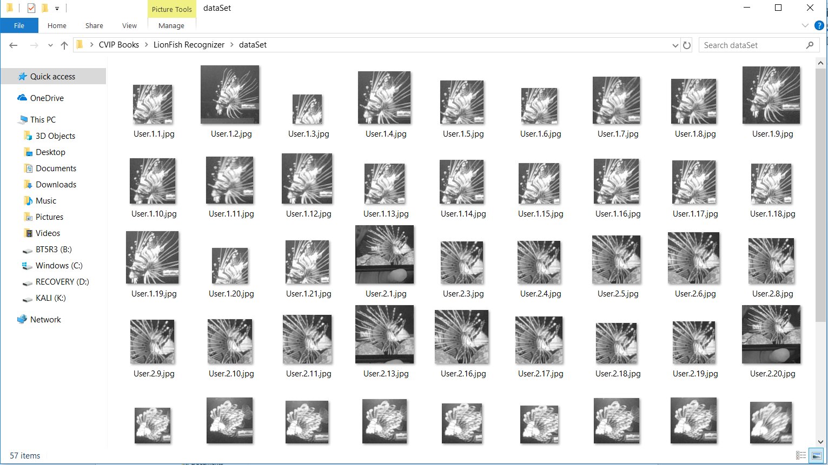

Figure - showing samples created for training

***b) Trainer***- This script trains our model to recognize lionfish. First we create the recognizer using the command

*cv2.createLBPHFaceRecognizer();*

We get the image samples from the data set folder and then we read it using the pillow library and then convert it to a numpy array. We then extract the id from the samples/image file name and store the images (or faces or samples) and ids in separate lists. As now we have the faces and ids we can train the recognizer using the command

*recognizer.train(faces,ids)*

And then we save the recognizer file created as trainer.yml in the training folder using the command *recognizer.save(‘trainner/training.yml)*.

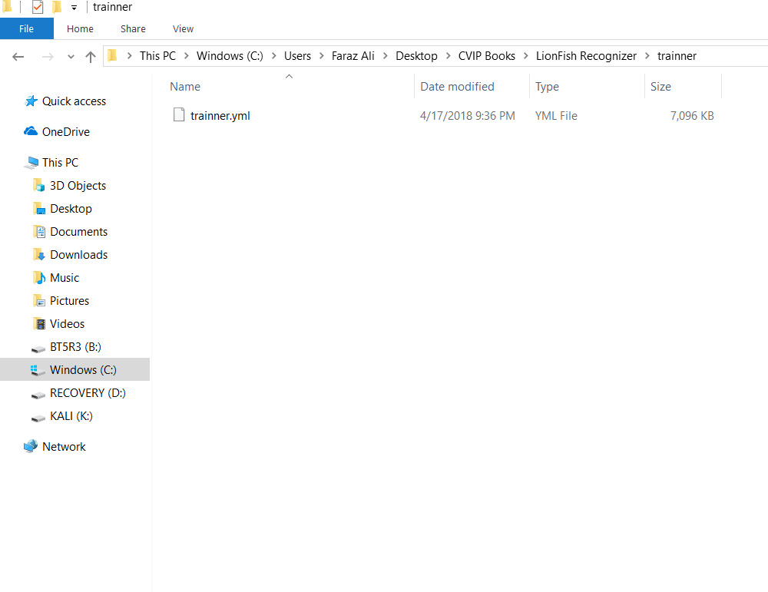

Figure - Showing the training file created

***c) Detector***- This script is similar to the face detection program. We create the recognizer again and load the recognizer file create previously. Now after detecting the faces from the camera we try to predict the id of the face detected. We use the command

*Id,conf=recognizer.predict(face array)*

And then display the ID below the face detected. Now with just some formatting we can say that

if id==1:

id=’Lionfish 1’

elif id==2:

id=’Lionfish 2’

.

.

.

.

else:

id=’Unknown’

**Experimentation:** I initially tried with 500 negative images and 250 positive images and as expected I was getting many false positives. I even tried to increase the number of classifier stages but this was leading to no detection. The problem was solved with using a large dataset and finding the optimum number of classifier stages, in our case it was 23. Things to consider in these cases are the amount of variation in object instances, the fact if you have a known/static background or not, is your lighting controlled or not but a general rule that works for a variety of setups is to take a numPos:numNeg ration of 1:2. Some applications require ratios of 100:1 and applications where the ratio is 1:100. It all makes sense once we know what training does for your application.

Keep in mind that increase the number of positives will increase the generalization of the model, it will look for better general features and will less likely over fit on your training data. Increasing the number of negative images is needed to remove the large amount of false positive detections. We want to supply as many situations as possible that don't look like your object here! Always keep in mind to carefully select the training data. It is better to have 100 good natural occurring samples, than to use 1 good image and transform it 100 times with the available tools.

I also noticed when creating the vector file and training the classifier the wxh parameter really matters as increasing this results in very long training times. -w and -h are the model dimensions, to which each new window is resized before training and which sizes are used to grab negative windows. We do not need to manually resize everything. The only thing we should guarantee is that the w:h ratio of the objects is about the same as the w:h ratio of the model dimensions.

***a) Effect on the training procedure***-The larger the dimensions the more features can be calculated and the more weak classifiers will be gathered for the boosting process. This also influences the amount of memory needed by the application, since all weak classifiers are stored in RAM memory during the process. If the application crashes due to not enough memory, we will need to reduce our model size.

***b) Effect on the detection procedure-***The wxh dimensions specify the smallest object size we will be able to detect. Objects larger than that will be detected by the multiscale image pyramid approach. Smaller objects will be ignored since upscaling images to be able to detect them introduces way to much clutter and rescaling artefacts.

**Test Dataset:**

 

Figure - Trained to recognize as Lionfish 1 Figure -Trained to recognize as Lionfish 2

 

Figure -Trained to recognize as Lionfish 3 Figure - Not trained to recognize

**Results: *Recognized Images***

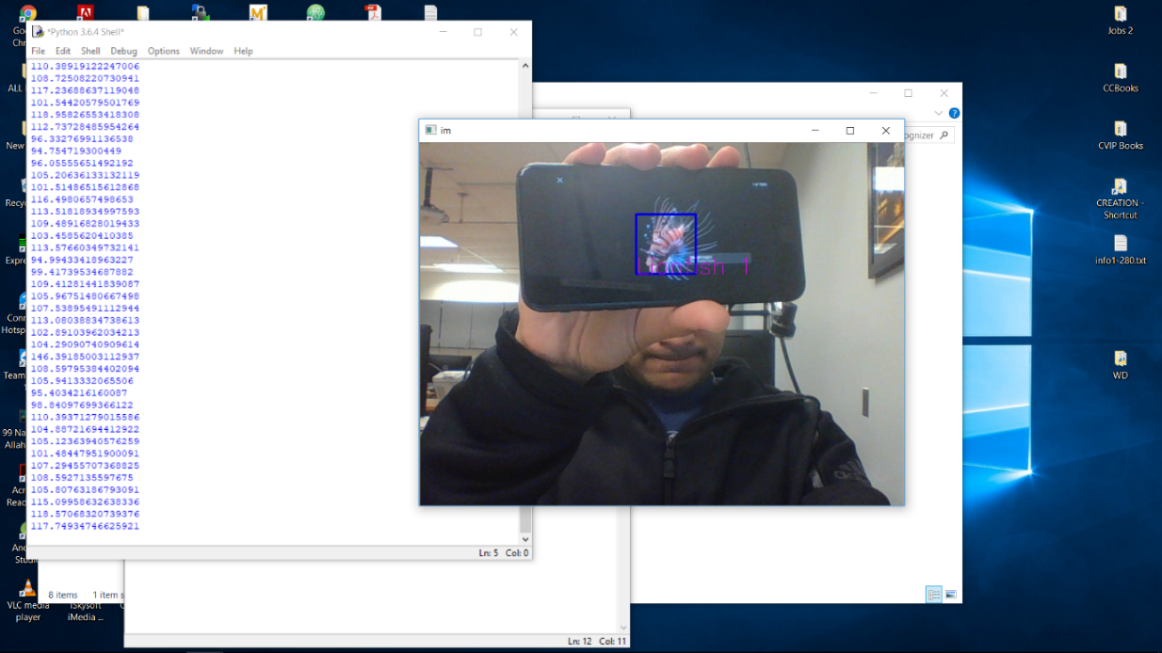

Figure - Showing Lionfish 1 recognized

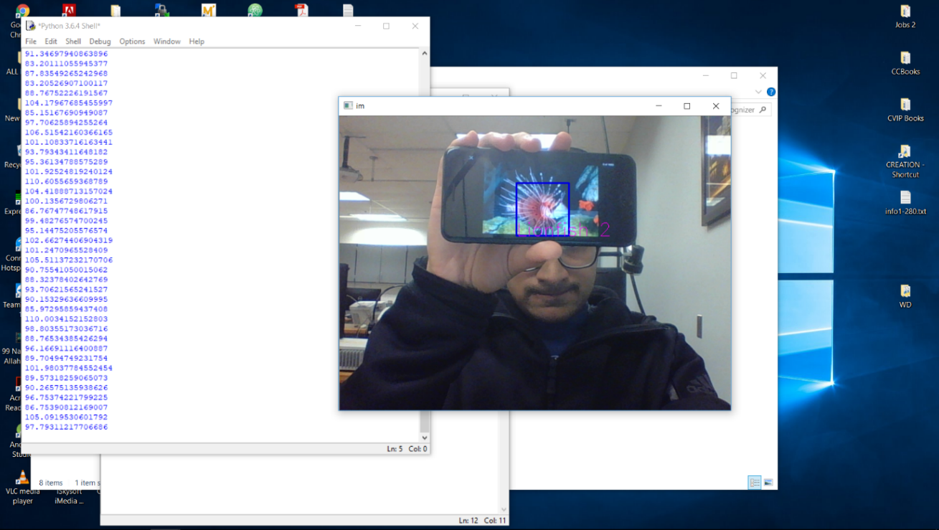

Figure 15- Showing Lionfish 2 recognized

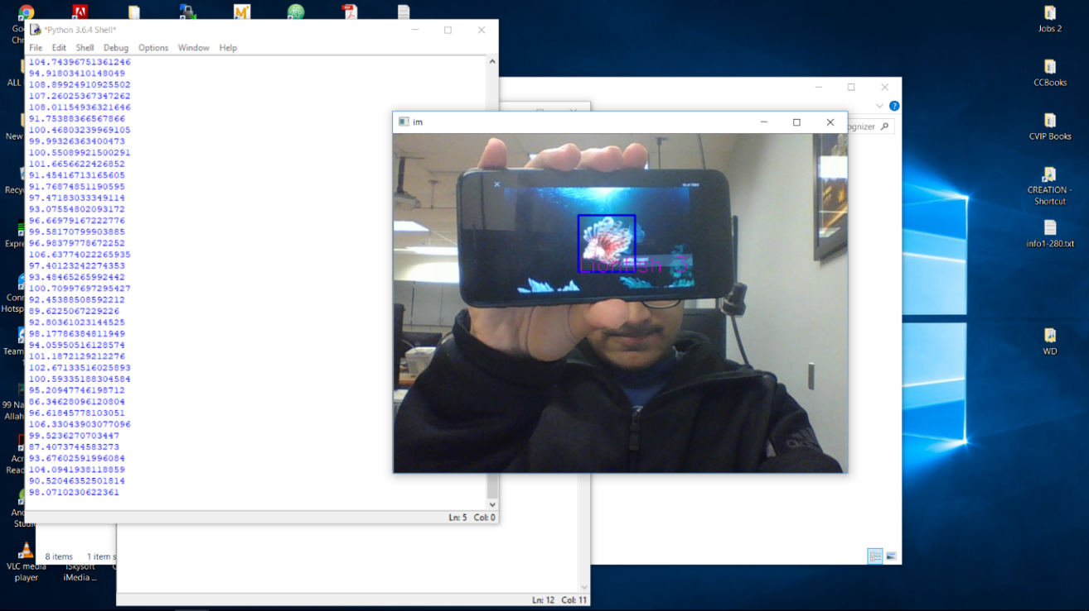

Figure 16- Showing Lionfish 3 recognized

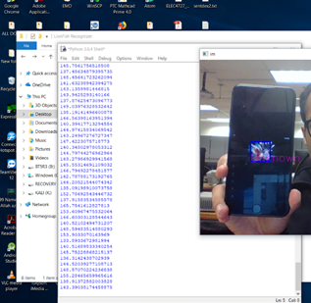

Figure 17- Showing Unrecognized

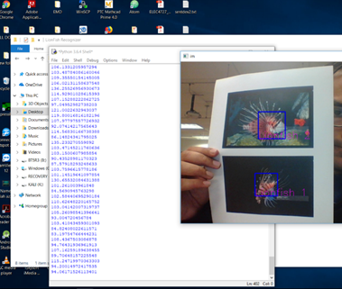

Figure 18- Showing Lionfish 1 and Lionfish 2 recognized

**Discussion:**

***Achievements-***

1. Able to detect most of the lionfish

2. Works well with both video and images

***Limitations-***

1. It does not work well in poor lighting condition.

2. The bounding box in some cases does not enclose the entire fish

3. It has detection rate of about 82%, 41 images detected from 50 test images.

***Future work-***

1. The accuracy of the detection can be increased by training with a larger data set of negative and positive images.

2. The recognition can be improved by using deep learning tools like tensor flow.

**References:**

1. TRAIN YOUR OWN OPENCV HAAR CLASSIFIER <http://coding-robin.de/2013/07/22/train-your-own-opencv-haar-classifier.html>

2. Training your own detector<https://www.youtube.com/watch?v=WEzm7L5zoZE>

3. Grabbing images <https://ww.image-net.org>

**Appendix:**

1. Python script to grab images from *www.image-net.org*

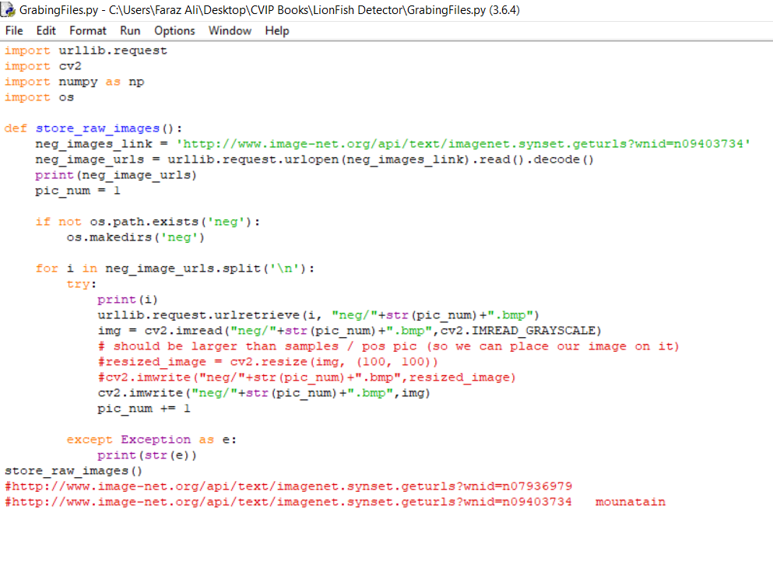

2. Python script to Remove ugly images from the the dataset

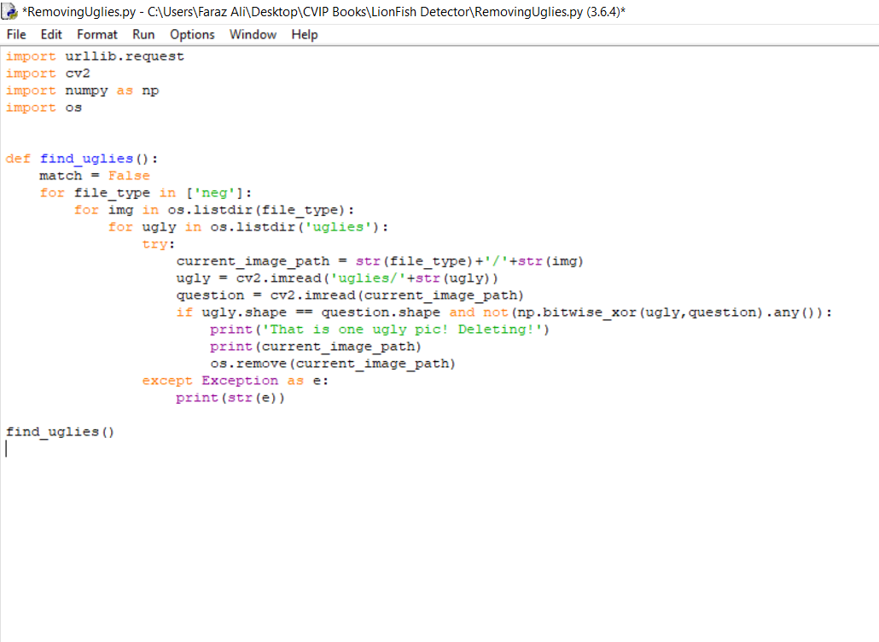

3. Python script to create the negative description file

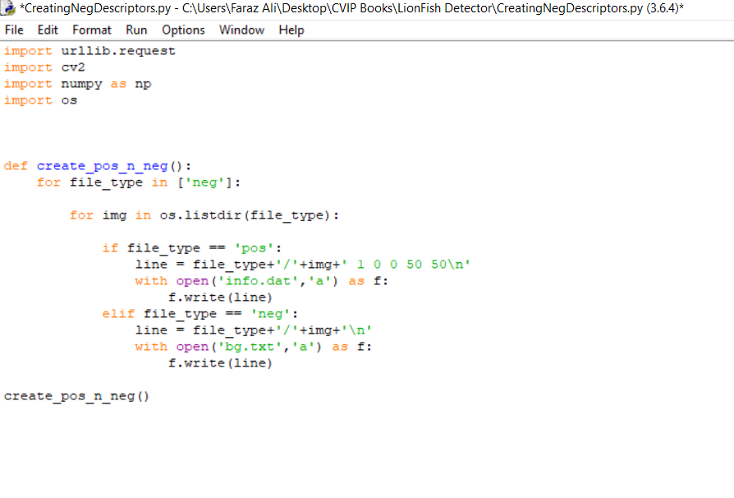

4. Python script to detect Lionfish

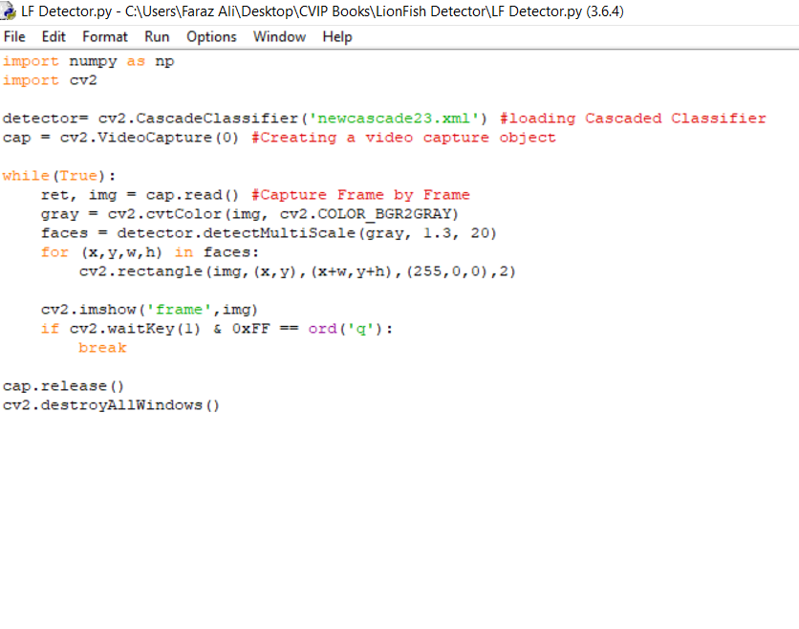

5. Python script to create samples for the detected lion fish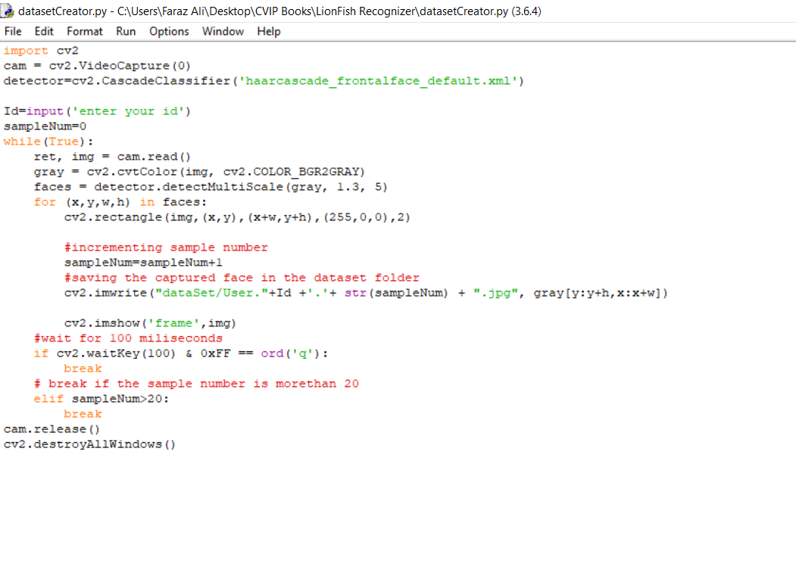

6. Python script to train the recognizer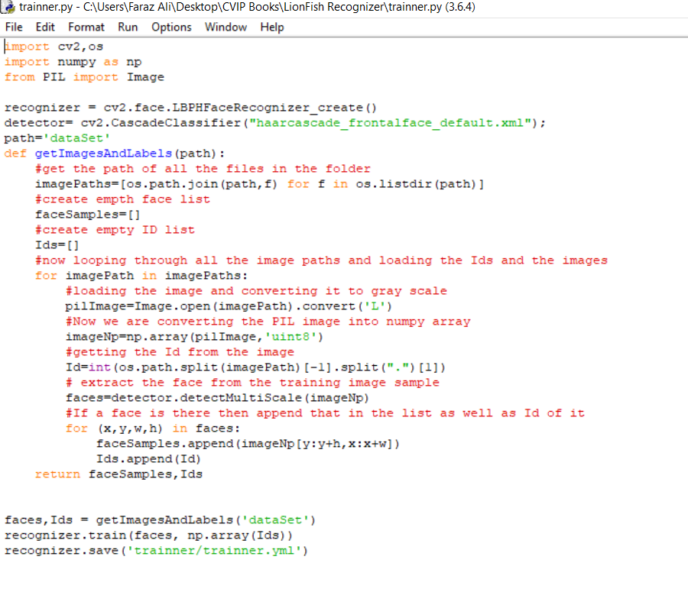

7. Python script to recognize lionfish

